Will be spotting patterns in the past will help make decision in directing and coordinating international health within the United Nations system today.

1. What was the population growth of the country with the highest population in 2008? Knowing this the WHO will have a better idea of where to reduce health risks due to overpopulation. Also, which country has the most cancer cases?
2. 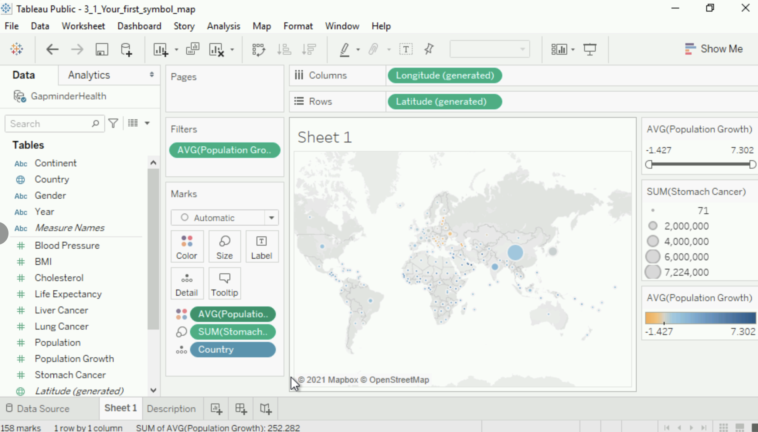
3. Is there seasonality to the number of births in Chile? If yes, during which month are the fewest babies typically born? Knowing this will help them plan how many resources should be sent over to ensure newborn care at birth throughout the year.
4. In January 2015 a record number of 13,543 people died in Portugal.

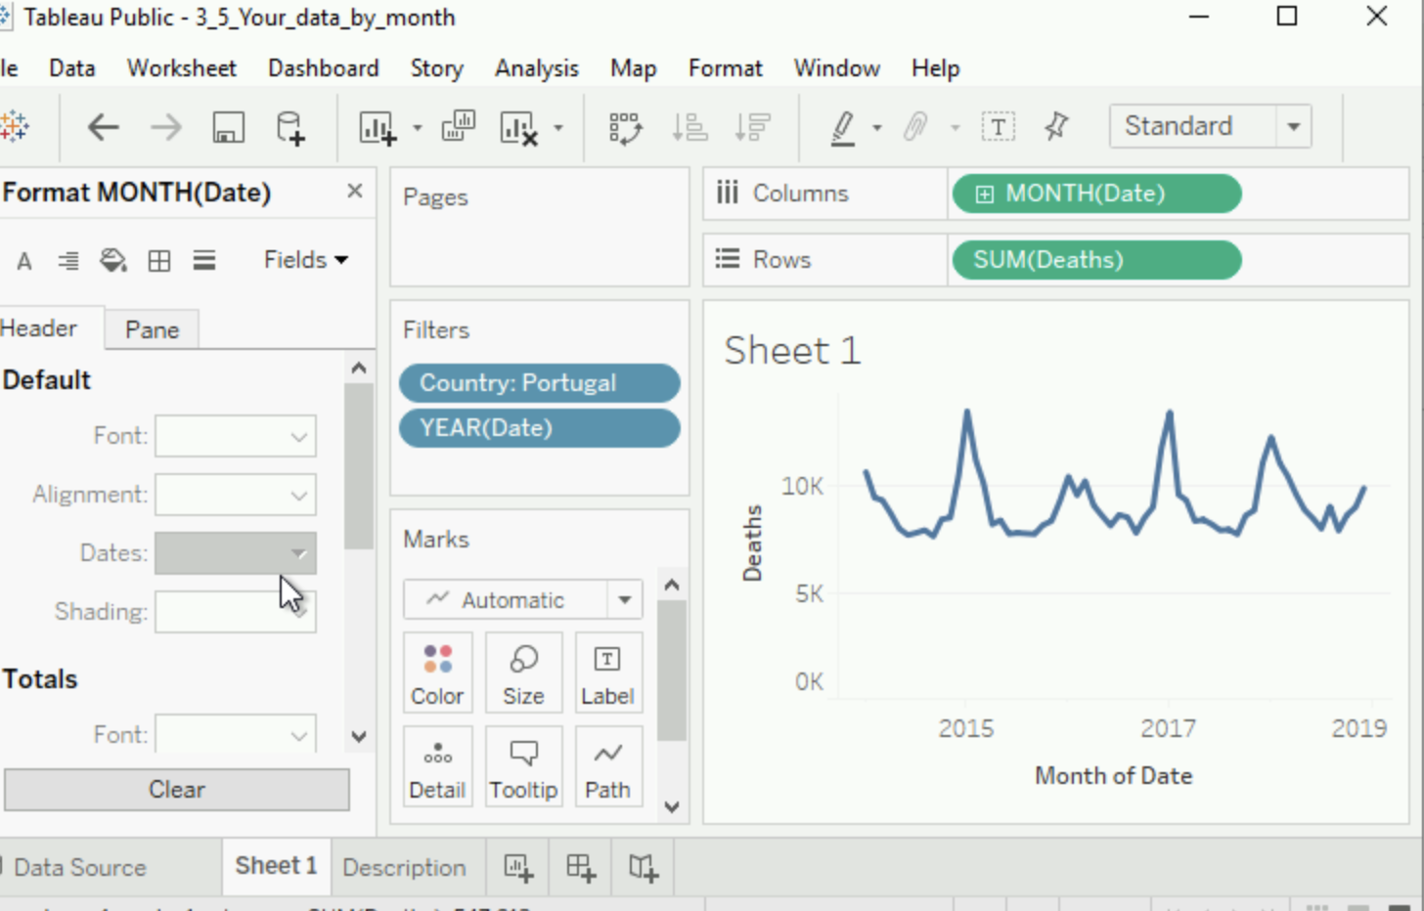

1. Looks like there is some seasonality to the natality data. During the 1995-1999 period each February there were less babies being born.

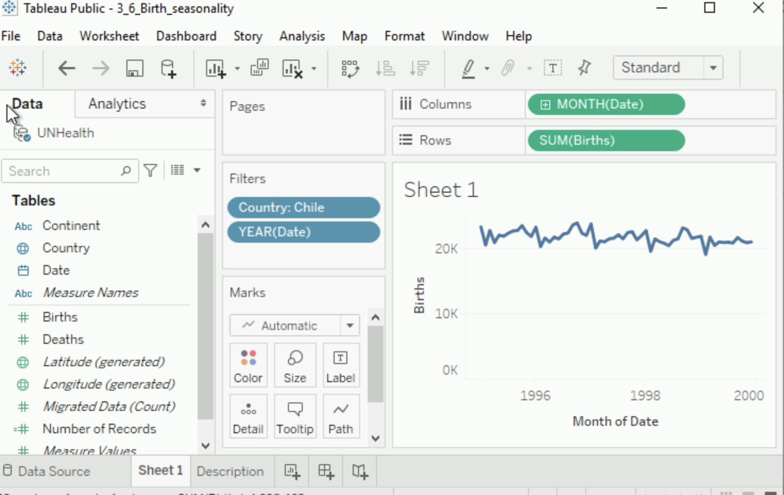

1. There are ways to enhance your data visualization with
   1. Reference Lines – is a reference line is drawn on a chart representing another measure or point of reference. For example, an reference line showing the average will easily show the difference of each mark in the char relative to the average.
   2. Trend lines – Trend lines are sued to predict the continuation of a certain trend. For example, a trend line can easily makes it easy to see that overall this measure is decreasing.
   3. Forecasting – is about predicting the future value of a measure. Mathematical models capture the evolving trend or seasonality of the data and extrapolate them into the future.
2. Is the forecasted number of deaths in Costa Rica during December 2019 higher than the average over the last five years? This will help the WHO decide if they need to focus more humanitarian effort in the area during that time period.
3. 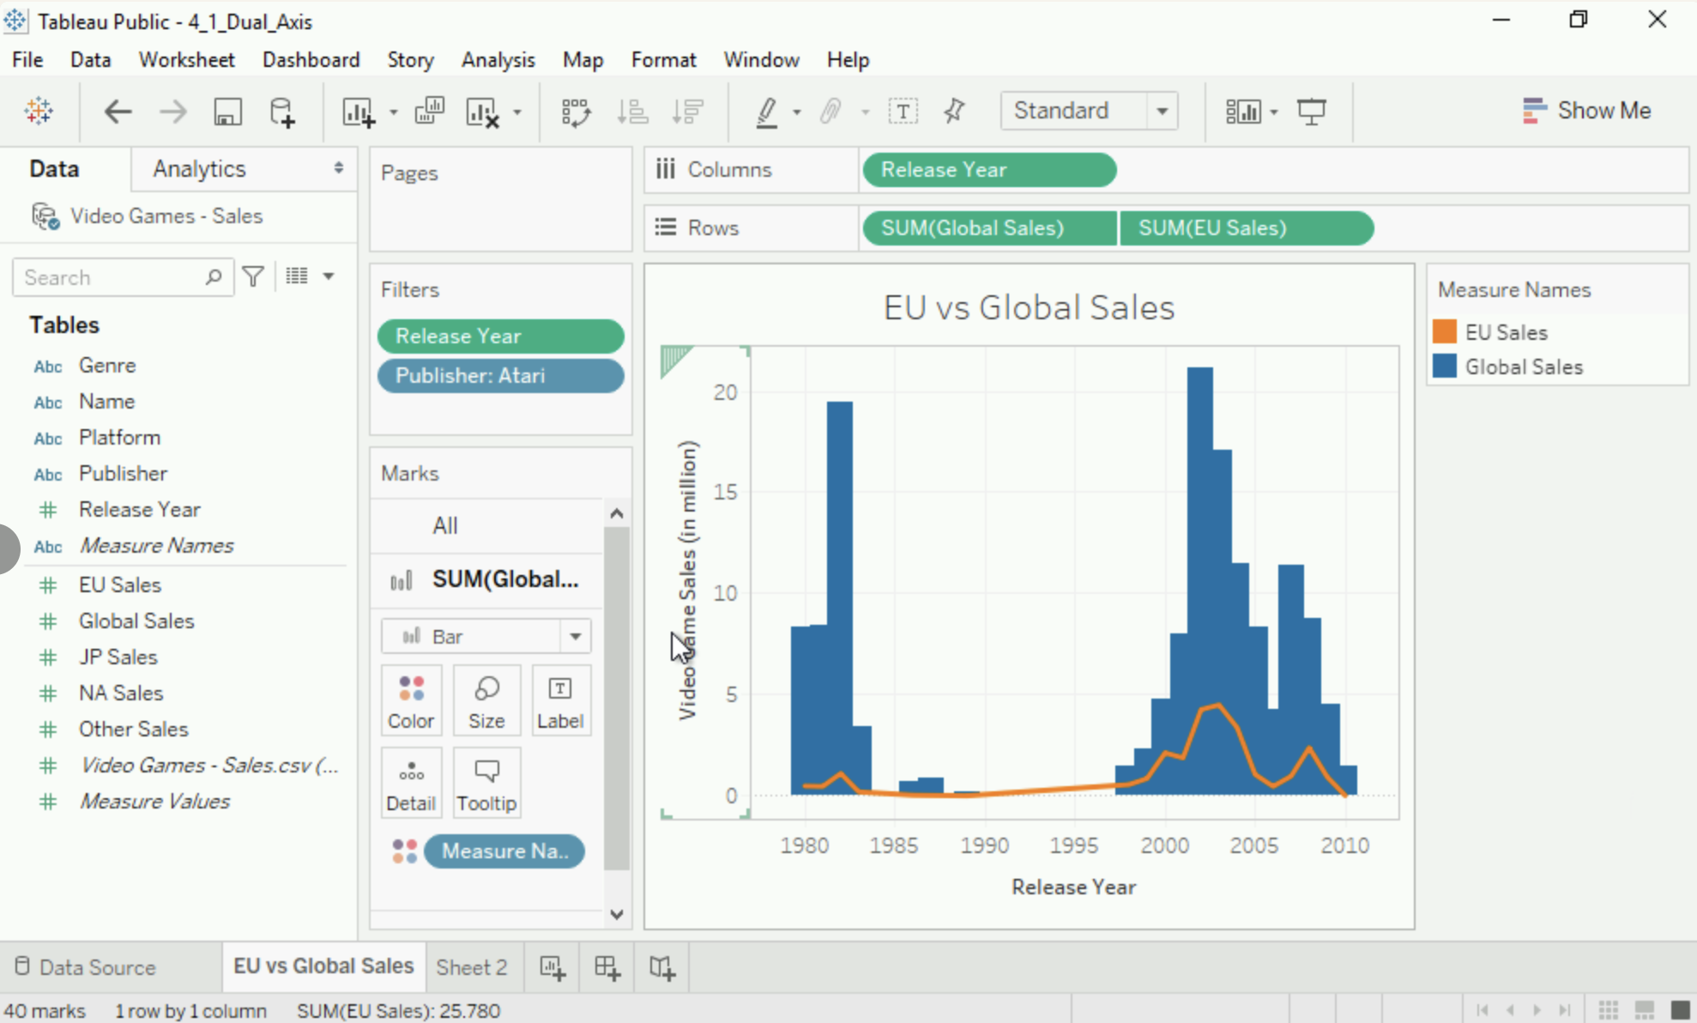

The huge spike in the puzzle genre in 1989 is thanks to the success of Tetris. It accounts for almost 90% of sales from that release year!

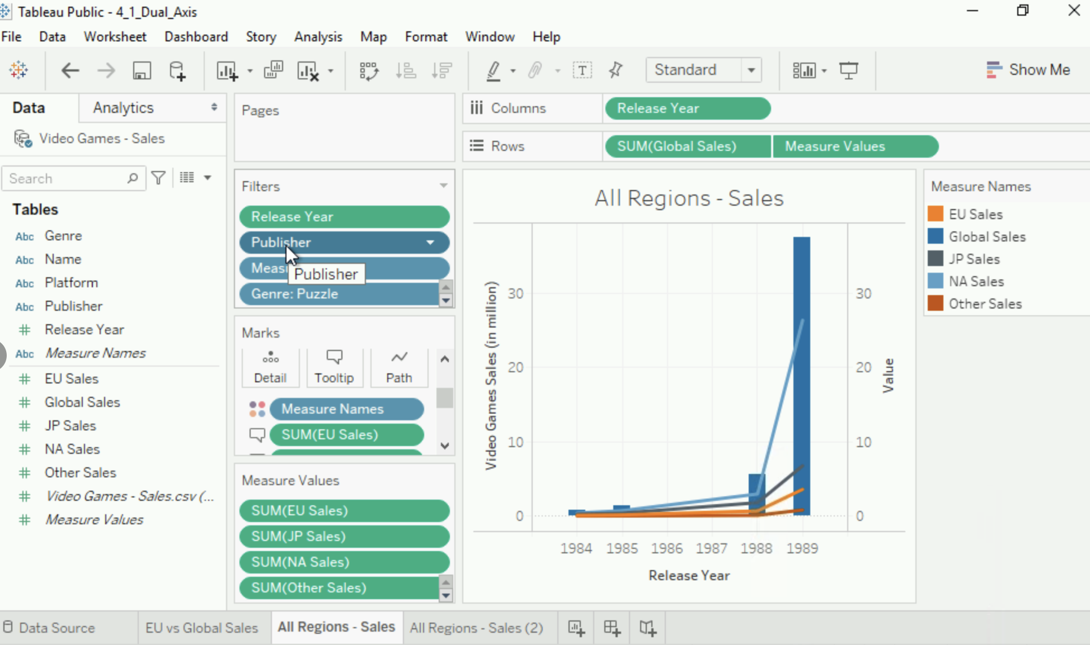

1. A Dashboard is a collection of several views
   1. Makes it easy to compare data
   2. Help uncover key insights
   3. Data is automatically connected to your worksheets
   4. More advance dashboards allow users to drill down and do their own analysis
      1. Views can be connected, allowing one view to function as an interactive filter
2. The first dashboard called “Platform Comparison” enable us to compare sales across Xbox, playstation, and Nintendo

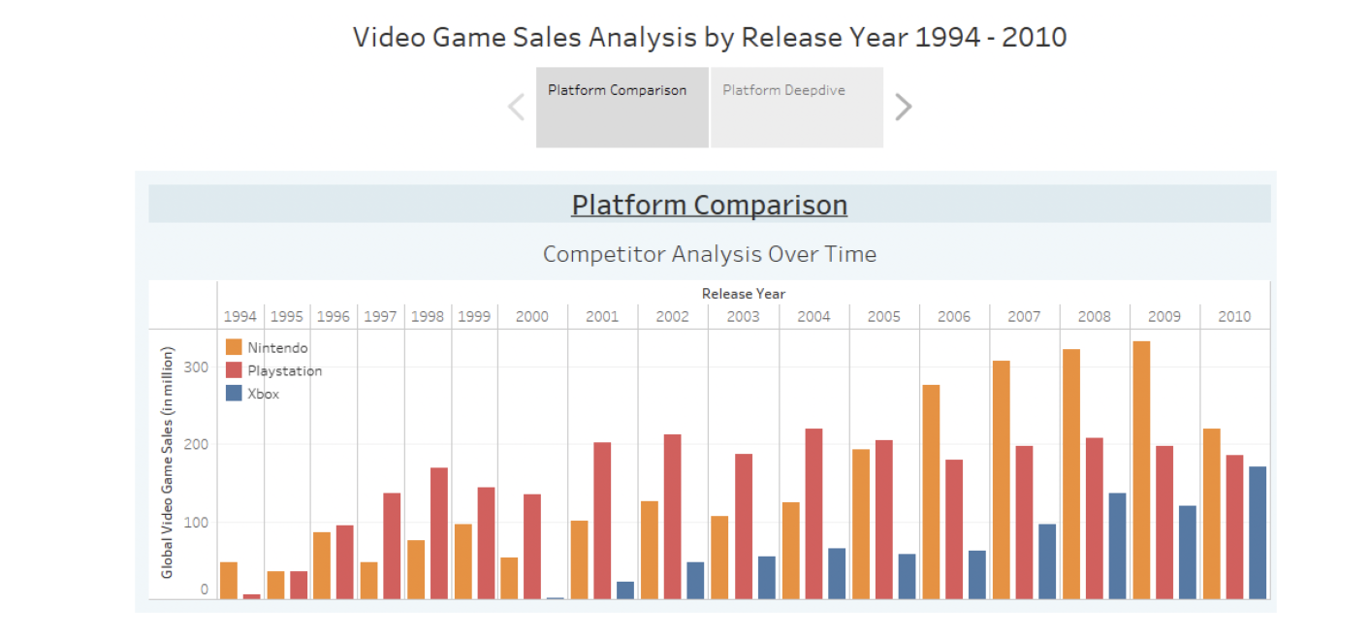

1. The second dashboard enables us to deep dive into a certain platform such as Playstation.

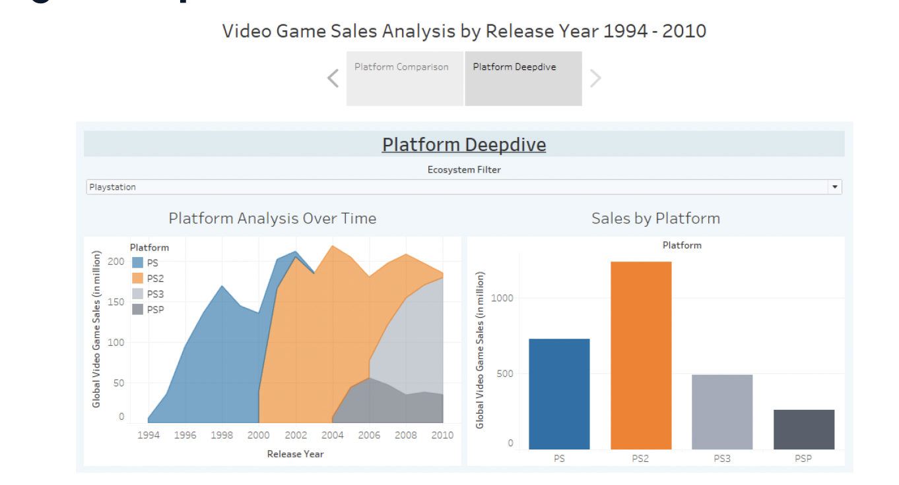

1. A story is a sequence of Visualizations
   1. Those visualizations (dashboards/worksheets) work together to convey information
   2. Very useful to tell a narrative, make a compelling business case
2. Worksheet:
   1. Contains a singe view, used to create graphs, tables and visualizations
   2. There is a Marks card available, which can be used to e.g. change color of a graph
3. Dashboard:
   1. A collection of views from multiple worksheets to present or monitor data, letting you compare a variety of data simultaneously
   2. Allows you to add interactively, end users can use it to drill down and do their own analysis in multiple sheets
4. Story:
   1. Best suited to tell a narrative or make a business case
   2. Sequence of dashboards and worksheets that work together to convey information